

|  |
| --- |
|  |
| Laboratory work 1 |

Contents

1. Virtual machine setting 3

2. GIT 3

3. CHOOSE BUSINESS FOR YOUR PROJECT 3

# 1. Virtual machine setting

1. Import VM “BI 2018.ova”.

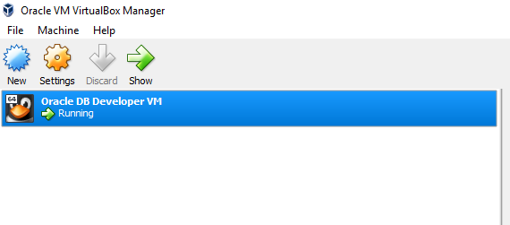

1. Set shared folder between your windows machine and remote machine

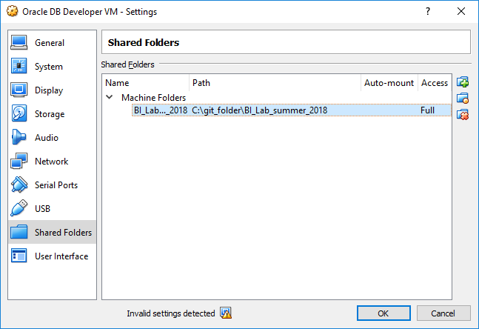

1. Connect to Oracle using SQL developer from Windows machine

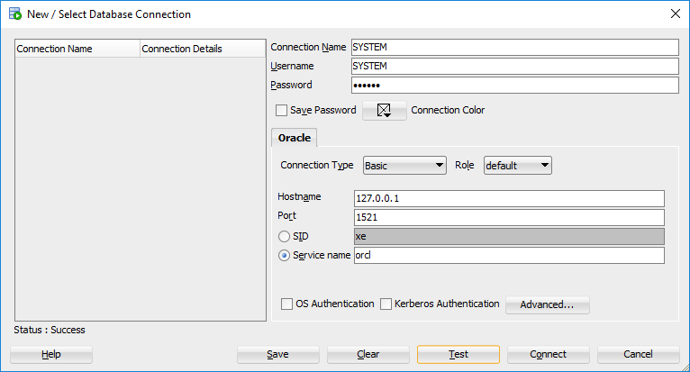

1. Create your user/schema

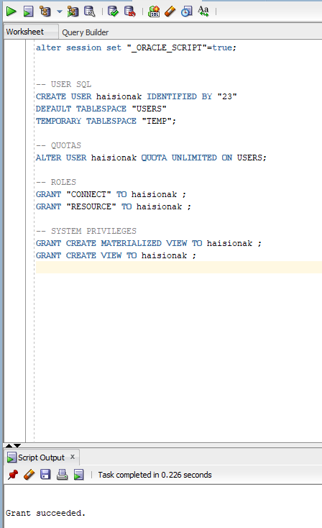

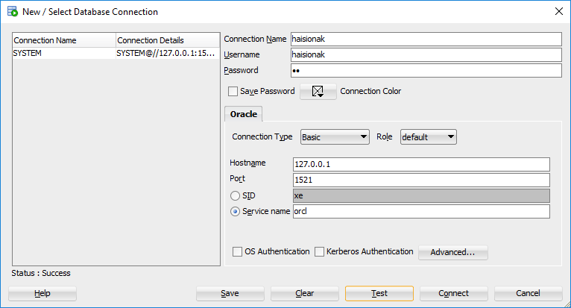

# 2. GIT

1. Pass GIT tutorial <https://githowto.com/>
2. Clone “BI_Lab_winter-spring_2018” repository

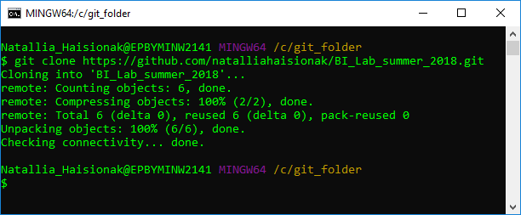

1. Add, commit and pull personal folders

